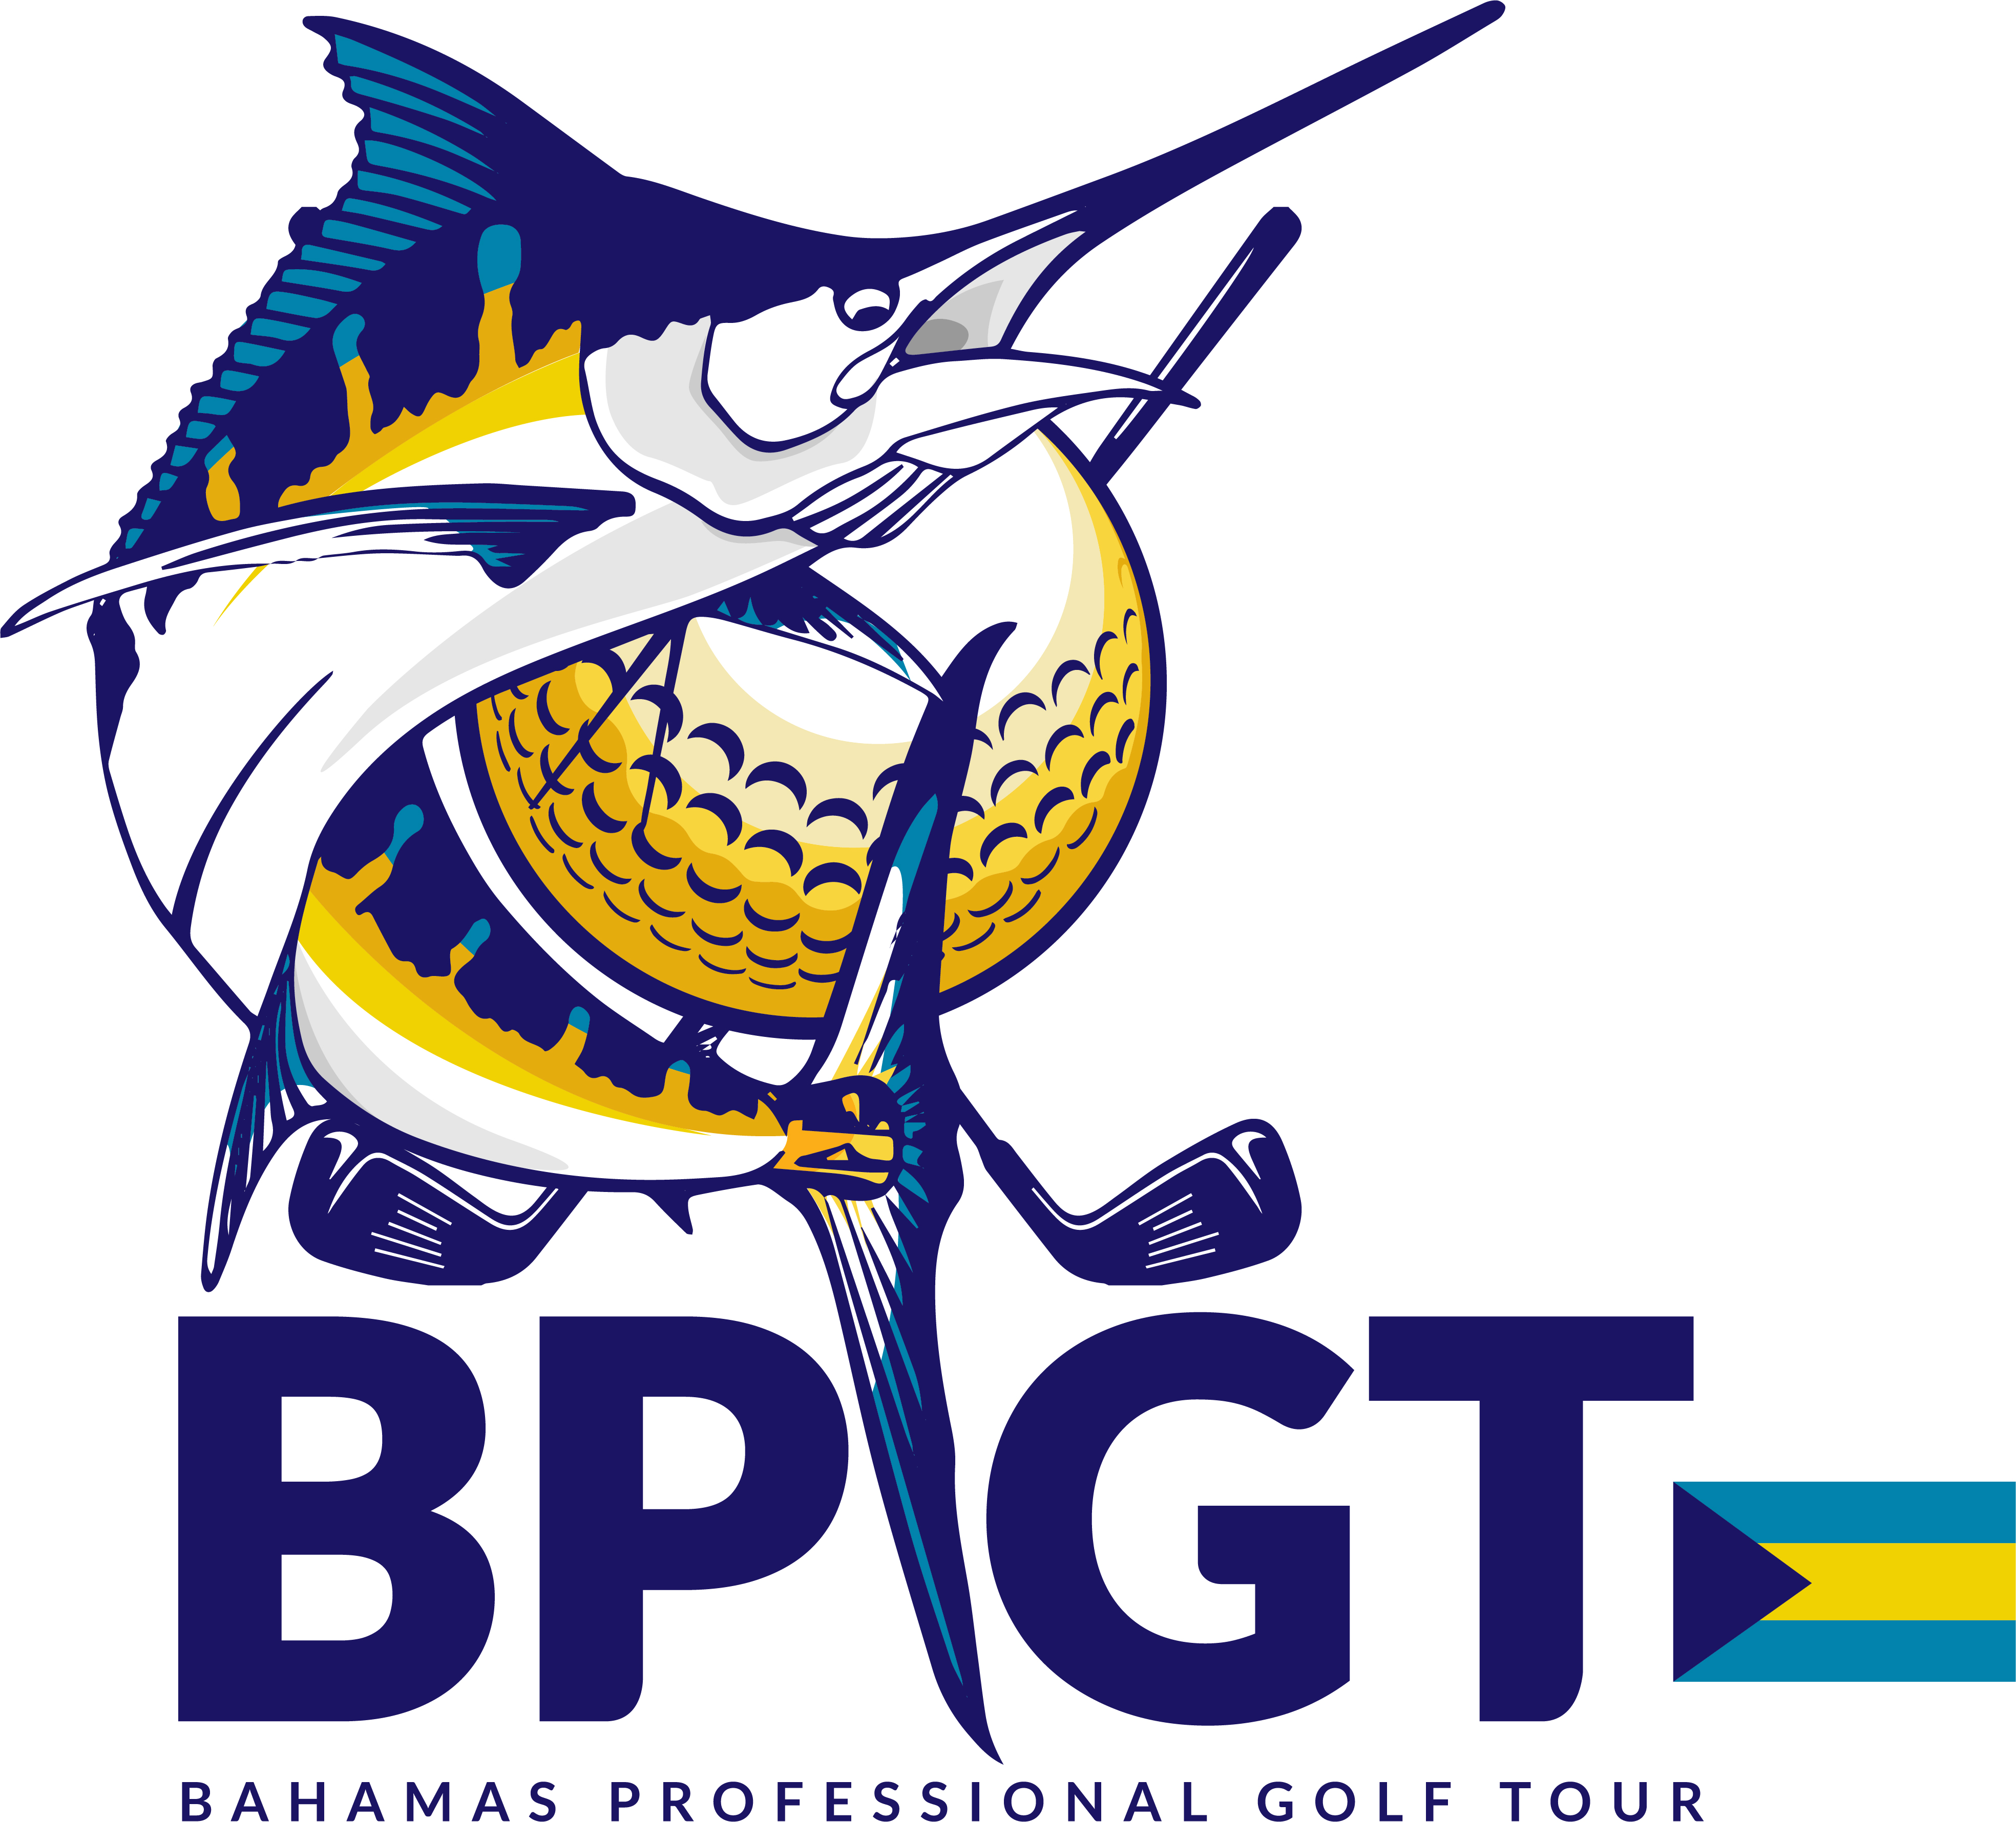

2018 BAHAMAS PROFESSIONAL GOLF TOUR
HALLOWEEN – PRO-AM

DATE: OCTOBER 26TH, 2018
TIME: Early Registration Thursday October 25th5:30 P.M.
TEE OFF: 2:30 PM
PLACE: Royal Blue Golf Course at Baha Mar
Nassau, Bahamas

ENTRY FEE: $150.00 Amateur Non Member
$130.00 Amateur Member
$200.00 Professional Non Member
$180.00 Professional Member

Format: 4 Amateurs plus PRO – OFFICIAL PRO/AM EVENT
Procedure: USGA rules and local rules apply
Handicap: USGA handicap

Cancelation Policy:
- If the golf tournament is canceled due to weather or other events, player will be allowed to play in another event during the series of events.
- If player cancels, 48-hour notice is required to receive 50% of entry fee.
- If player is a no-show, entry fee is non-refundable.

ENTRY FORM: MEMBERSHIP MEMBERSHIP FEE
$100.00 ANNUAL

NAME OF PROFESSIONAL: ________________________________________

TELEPHONE: __________ GHIN NO. _______________ HANDICAP ______

EMAIL: __________________________________________________

DESIGNATION: PROFESSIONAL________AMATEUR___________(JR.AGE)____

If competing on a team, please list below team members:

Player 1 Name: _________________________________________

Player 2 Name: _________________________________________

Player 3 Name: __________________________________________

Player 4 Name: __________________________________________

* Please have each team member fill out an entry form

Field is limited, please register with payment to secure a spot!

WAIVER AND RELEASE: Player certifies that s/he is physically fit and has not been advised otherwise by a licensed medical professional. Player voluntarily assumes all risk and danger incidental to participation in attendance at the golf tournament and related activities, from known, unknown, obvious and hidden conditions, including without limitation, being struck my misdirected golf balls, falls on and/or around the golf course site, use/misuse of equipment (including defective equipment), and actions of third parties. By participating in the golf tournament, and his/her heirs, executors, administrator and assigns agree to release, indemnify, and hold harmless tournament sponsors and organizers (collectively, “Releases”) from and against any and all injuries, losses, damages, claims, actions and any liability of any kind (including, without limitation, personal injury, death, or loss or damage to personal, private, or other property), whether or not due to the negligent acts of omissions of the Releases, resulting from or arising out of Player’s attendance at and/or participation in the golf activities. All photos taken remain the property of BPGT and can be used for promotional purposes.
PLAYER SIGNATURE: ___________________________________________

PLAYER SIGNATURE DESIGNATE IF UNDER 18_______________________

2018 Golf Committee

Dion Godet
Tournament Director

Dr. Cornell Collins
Rules Official

Riccardo Davis Jr.
Tournament Organizer
242-433-6303

Mailing Address
P. O. Box N-1662
Nassau Bahamas
Email:
bahamasprofessionalgolftour@gmail.com

* Send Entry Forms
to this email address
bahamasprofessionalgolftour@gmail.com

Applications and payment can
Also be dropped off at
Royal Blue Golf Course
Attn: Riccardo Davis BPGT

Checks payable to:
Bahamas Professional Golf Tour

